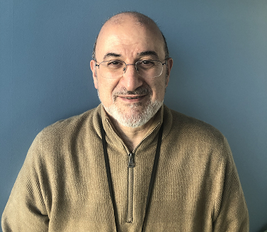

Dr. Ra’id Awadallah received his Ph.D. in Electrical Engineering from Virginia Tech in 1998. He joined Johns Hopkins University Applied Physics Laboratory in the same year and he is currently a member of the principal professional staff. Over the last 23 years, he has led a team of researchers developing efficient numerical models for tropospheric propagation, electromagnetic scattering from randomly rough surfaces, radar cross-section of complex targets, pulsed propagation in complex urban structures, and characterization of thin-film metamaterials. Dr Awadallah is also an adjunct professor at the Johns Hopkins University Engineering Program for professionals where he teaches courses on basic and applied electromagnetism.

Prior and in parallel to his pursuit of the technical disciplines, Dr. Awadallah spent many years studying various Islamic disciplines such as Arabic Language, Tafseer, Fiqh and Hadeeth. He has been teaching these various Islamic disciplines, especially Arabic Language and Tafseer, at various masajid in the Baltimore area since 1998.

