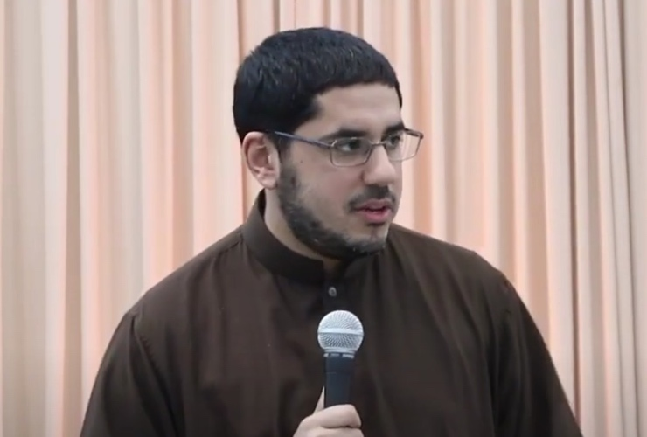

Mobeen Vaid is a Muslim public intellectual and writer. A contributing writer for muslimmatters.org, his writings center on how traditional Islamic norms and frames of thinking intersect the modern world. In recent years, he has focused on Islamic sexual and gender norms. Vaid also speaks at confessional conferences, serves as an advisor to Muslim college students, and was campus minister for the Muslim community at George Mason University. He has reviewed The Study Qur’an for the Journal of Islamic Sciences and published “Can Islam Accommodate Homosexual Acts? Qur'anic Revisionism and the Case of Scott Kugle” for the American Journal of Islamic Social Sciences (AJISS).

