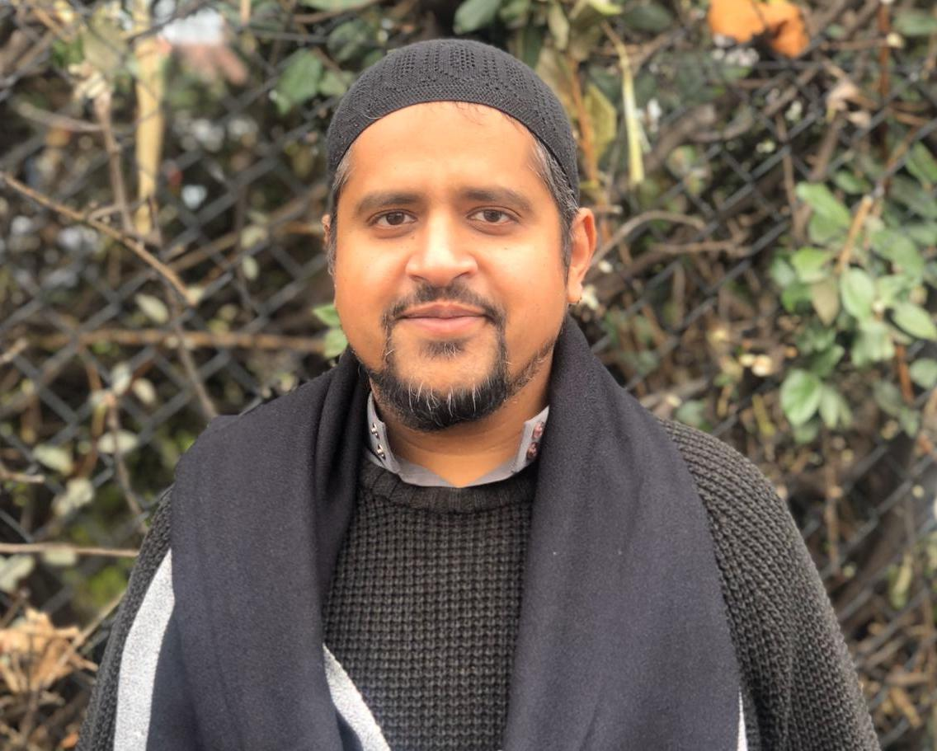

Imam Yaseen Shaikh was born in 1982 to parents of Indian origin in Hackney, London, UK where he lived for much of his life. He obtained all his religious education including memorization of the entire Quranic text, Alimiyyah Studies (Rigorous Islamic Theology Program), and certification in issuing Fatwa (religious verdicts), from traditional seminaries in London. He completed a diploma and M.A in Islamic Studies from Birkbeck College, University of London. All his education was received in London, UK.

Imam Yaseen has served as an Imam since 2002 in Stoke Newington, London, where he was also Head of Islamic Studies at a private school, Tawhid Secondary School. As an Imam, Imam Yaseen was involved with the spiritual activities of the Mosque, as well as outreach and civic activities, diversity training and working with various organizations on an advisory level.

In 2006, Imam Yaseen moved to the USA to serve at a Mosque in Dallas, Texas. Later he joined the Muslim Community in Baltimore, Maryland as Resident Scholar.

As an Imam in the USA, Imam Yaseen engaged in spiritual and educational activities, catering to a wide range of members of the community. He was deeply engaged in multi faith dialogue and implemented initiatives to enhance the work and profile of the Muslim Community in the wider society. He also offered pastoral care and counselling to members of the Community.

In 2018, Imam Yaseen returned to the UK to be closer to his family. He served as an Imam and bereavement counselor at the largest and only dedicated Muslim Cemetery in the UK, Gardens of Peace. Here he performed the end-of-life rituals, offered bereavement counselling and support, and provided training on Muslim end of life matters to a variety of institutions.

Imam Yaseen very recently moved back to the Baltimore area with his wife and three daughters. He is an avid football fan and enjoys time with family and friends.

